Macro4 DUMPMASTER Z 8800A Feb 2023
Created M4 ticket at https://support.macro4.com to order current Dumpmaster version. I received an email with the order. Note: M4CS (Common Services) came with the order and it was a newer version than what we are currently running (which is M4CS 2800C ).
Glenn Havelock ( glenn.havelock@unicomsi.com ) verified that we can upgrade Common Services at a later date and is not necessary to be at M4CS 2810C to run this Dumpmaster Z 8800A.

Download the release notes and all other associated software files.
Inside the email, click the links to access the files via the HTTPS URL and use the provided password to download the files.

When you click the link for a file to be downloaded, It will ask for the password and look like this:

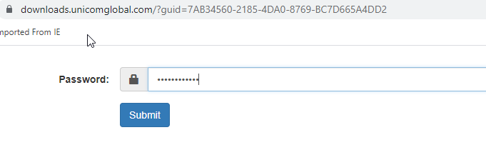When you click submit, it will prompt you for the location to place the file.
I created a folder on the V Drive to hold all the files and Word docs for M4DM 88700A
V:\CORPDATA02\D0003\Unit6\OPSYS\Macro4 Software\DumpMaster\Dumpmaster Z 8800A

Review the DMZ8800A.RELEASE.NOTE.pdf and it showed this:
Installing the product
Instructions for receiving and loading the product installation files can be found in the file
DMZ8800.INSTJCL.TXT

Review DMZ8800.INSTJCL.TXT has FTP instructions to upload the XMIT file from M4DM to SBX1. Since FTP is not authorized currently at HM, copied the attributes of SYS3.MACRO4.MDMO870E.BINSTART and allocated SYS3.MACRO4.MDMO880A.BIN.
IND$FILE was used to send the DMZ8800A.XMIT file to SYS3.MACRO4.MDMO880A.BIN.

Instructions then state:
Before you can proceed with the installation, you need to RECEIVE the dataset that you have uploaded.

Created SYS3.MACRO4.MDMO880A.INSTALL to contain all the jobs that are used for this installation. Job TECH.GHG.LIB(XMITRECL) was copied to be used to receive SYS3.MACRO4.MDMO880A.BIN and create SYS3.MACRO4.MDMO880A.UNPACK. The job failed due to “not enough space on volume” so the JCL needed changed to include a VOL(SB0515) parm before the UNPACK dataset and remove the RESTORE parm. See job XMITRECV.

I created SYS3.MACRO4.MDMO880A.INSTALL.OUTPUT to hold SYSOUTs of the jobs.
XMITFAIL shows the issue trying to use the RESTORE parm and XMITRECV shows the successful creation of SYS3.MACRO4.MDMO880A.UNPACK after the JCL was corrected.

Note: A backup copy of SYS3.MACRO4.MDMO880A.BIN was created BEFORE running XMITRECV
SYS3.MACRO4.MDMO880A.BIN
SYS3.MACRO4.MDMO880A.BIN.BKUP

XMITRECV created SYS3.MACRO4.MDMO880A.UNPACK
Command ===>
Name Prompt Size Creat
_________ $README
_________ F1U
_________ F2
_________ F3
_________ F4
_________ F5
_________ F6
_________ F7
_________ INSTALL
_________ SMPPTFIN
**End**

Created a backup copy of SYS3.MACRO4.MDMO880A.UNPACK calling it *.UNPACK.BKUP

Copied SYS3.MACRO4.MDMO880A.UNPACK($README) and put it into SYS3.MACRO4.MDMO880A.INSTALL(DMREADME)
Customized and submitted it. The 3rd qualifier was left as MDMO880 due to the comment in $README indicating to do so.

Starting datasets:
SYS3.MACRO4.MDMO880A.BIN
SYS3.MACRO4.MDMO880A.BIN.BKUP
SYS3.MACRO4.MDMO880A.OUTPUT
SYS3.MACRO4.MDMO880A.UNPACK
SYS3.MACRO4.MDMO880A.UNPACK.BKUP
SYS3.MACRO4.MDMO880A.INSTALL
SYS3.MACRO4.MDMO880A.INSTALL.OUTPUT

After SYS3.MACRO4.MDMO880A.UNPACK($README)
Saved output into: SYS3.MACRO4. MDMO880A.INSTALL.OUTPUT (DMREADME)

The job built these files:
SYS3.MACRO4.MDMO880.F1
SYS3.MACRO4.MDMO880.F2
SYS3.MACRO4.MDMO880.F3
SYS3.MACRO4.MDMO880.F4
SYS3.MACRO4.MDMO880.F5
SYS3.MACRO4.MDMO880.F6
SYS3.MACRO4.MDMO880.F7
SYS3.MACRO4.MDMO880.INSTALL
SYS3.MACRO4.MDMO880.SMPPTFIN

===========================================================================
Per Jerry’s instructions, SYS3.MACRO4.MDMO880.F4(##README) was converted to a PDF document and printed it for later use.
===========================================================================

SYS3.MACRO4.MDMO880.INSTALL(##README) states to execute JCLPREP to create JCL for SMPE jobs.
__ex_____ JCLPREP creates a panel to fill in HLQ for SMPE libraries and more. Below is a screen shot of what was customized:
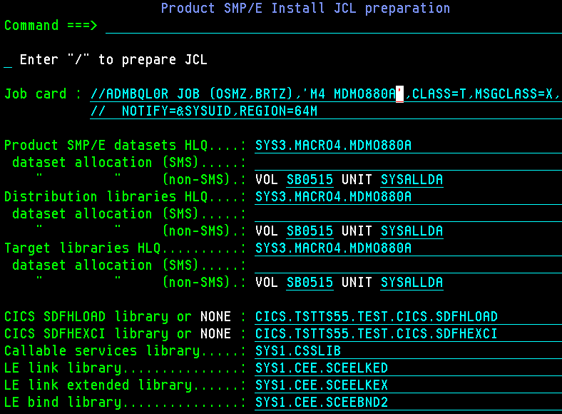

Verified CICS, CEE and CSSLIB was correct by checking TEST and SBOX APF and libraries in =3.4.

/ was then entered to prepare and create the JCL for jobs. This is what was returned:
Creating install JCL SYS3.MACRO4.MDMO880.INSTALL(SMPEJOB5). RC=0
Creating install JCL SYS3.MACRO4.MDMO880.INSTALL(SMPEJOB6). RC=0
Creating install JCL SYS3.MACRO4.MDMO880.INSTALL(SMPEJOB7). RC=0
Creating install JCL SYS3.MACRO4.MDMO880.INSTALL(SMPELIST). RC=0
Creating install JCL SYS3.MACRO4.MDMO880.INSTALL(SMPEINST). RC=0

SBX1 EDIT SYS3.MACRO4.MDMO880.INSTALL
Command ===>
Name Prompt Size Created
_________ JCLPREP *RC=0

SYS3.MACRO4.MDMO880.INSTALL(##README) says to run SMPEINST -
Contains steps to DEFINE, RECEIVE, APPLY, and ACCEPT the product and associated service, and perform Post-installation copies.
Copied SYS3.MACRO4.MDMO880.INSTALL(SMPEINST) to
SYS3.MACRO4.MDMO880A.INSTALL(SMPEINST)
Submitted it.
Saved SYSOUT to: SYS3.MACRO4.MDMO880A.INSTALL.OUTPUT(SMPEINST)

FILE ALLOCATION REPORT:
DDNAME DDDEFNAM SMPDDNAM TYPE --------------DATA SET OR PATH--

SMDMCLIB SMDMCLIB PERM SYS3.MACRO4.MDMO880A.SMDMCLIB
SMDMDBRM SMDMDBRM PERM SYS3.MACRO4.MDMO880A.SMDMDBRM
SMDMEXEC SMDMEXEC PERM SYS3.MACRO4.MDMO880A.SMDMEXEC
SMDMILIB SMDMILIB PERM SYS3.MACRO4.MDMO880A.SMDMILIB
SMDMINST SMDMINST PERM SYS3.MACRO4.MDMO880A.SMDMINST
SMDMLINK SMDMLINK PERM SYS3.MACRO4.MDMO880A.SMDMLINK
SMDMLOAD SMDMLOAD PERM SYS3.MACRO4.MDMO880A.SMDMLOAD
SMDMMENU SMDMMENU PERM SYS3.MACRO4.MDMO880A.SMDMMENU
SMDMPARM SMDMPARM PERM SYS3.MACRO4.MDMO880A.SMDMPARM
SMDMPENU SMDMPENU PERM SYS3.MACRO4.MDMO880A.SMDMPENU
SMDMPROC SMDMPROC PERM SYS3.MACRO4.MDMO880A.SMDMPROC
SMDMSENU SMDMSENU PERM SYS3.MACRO4.MDMO880A.SMDMSENU
SMDMTENU SMDMTENU PERM SYS3.MACRO4.MDMO880A.SMDMTENU
SMDMUTIL SMDMUTIL PERM SYS3.MACRO4.MDMO880A.SMDMUTIL

======================================================================
NEXT: The instructions in SYS3.MACRO4.MDMO880.INSTALL(##README) says:
Now proceed to hlq.SMDMINST(##README)

SYS3.MACRO4.MDMO880A.SMDMINST(##README) says:

Two such executables are shipped with this dataset:
#INSTALL creates the JCL members needed to configure the product.
#ROLLOUT clones the product for multiple MVS systems. Not used.

#INSTALL is an executable - Option 1 for INPUT
Specify jobcard details.
//ADMBQL0R JOB (OSMZ,BRTZ),'M4 MDMO880A',CLASS=T,MSGCLASS=X,
// NOTIFY=&SYSUID,REGION=64M
//*
//*

SMS alloc parms (optional). . . . . .
Unit/Volser (reqd. for Non-SMS) . . . SYSALLDA SB0515

Specify the dump file to be used with the product Startup JCL
DSN . . . . TOSM0.MACRO4.DM.SYSF.BATCH.DUMPFILE

Specify the Macro 4 Common Services Dataset prefix
HLQ . . . . SYS1.MACRO4.MC

Press Enter to continue, or END to Exit.

OPTION 2 builds the JCL in from SYS3.MACRO4.MDMO880A.SMDMINST(Z@CSDUPT) to SYS3.MACRO4.MDMO880A.SMDMINST(@CSDUPT) as an example

40 of 40 members were processed. Results are logged in SYS3.MACRO4.MDMO880A.SMDMINST(ZLOG)
***

Option 3 is if you want to select / prepare any of the individual JCL / install jobs. This was not needed so not used. This ends the #INSTALL member.
****
Ran SMPEJOB5 to RECEIVE Macro4 Dumpmaster PTFs – RC04 due to PTF DM03969 NOT RECEIVED ALREADY APPLIED AND ACCEPTED
Subsequently, SMPEJOB6 to APPLY Macro4 Dumpmaster PTFs was not run and
SMPEJOB7 to ACCEPT Macro Dumpmaster PTFs was not run.

Run compare against MDMO850F libraries SYS1 (RUNTIME) AND and MDM0880A libraries SYS3 (INSTALL).
See SYS3.MACRO4.MDMO880A.INSTALL.OUTPUT(DMCOMPR1-4)
DUMPMSTR
M4DMCSYD
M4NOTIFY
DMPBCNTL

Create a USER library with the unmatched members that may need carried over from the previous version (if they exist like the ones above). Not needed since the members identified above exist with the 880A version.

CICS Consideration for Nagy:
Compare SYS3.MACRO4.MDMO880A.SMDMUTIL(DMDFHDUP) and found no concerning changes.
Job @CSDUPT in SYS3.MACRO4.MDMO880A.SMDMINST was created by SYS3.MACRO4.MDMO880A.SMDMINST(##INSTALL) and is for CICS RDO definitions. This is used to define the DM definitions with in CICS.TSTTS55.TEST.CICS.DFHCSD.
Compared SYS3.MACRO4.MDMO880A.SMDMINST(Z@CSDUPT) to SYS3.MACRO4.MDMO850F.SMDMINST(Z@CSDUPT)
Save the output to SYS3.MACRO4.MDMO880A.INSTALL.OUTPUT(DMCICCMP) and no differences (added or deleted) noted for Jim Nagy to update in CATS

Provide Nagy with TS 5.6 and 6.1 RDO entries to prepare for those versions in the future. It does no harm to add these definitions to CATS. They just will not be used until then new versions of CICS are in use. Send Jim an email with the job SYS3.MACRO4.MDMO880A.SMDMINST(@CSDUPT)

Complete the SYS3.MACRO4.MDMO880A.SMDMINST(##README)
Dumpmaster Panel access information:
PANELID to see what panel you are in on SDSF screens. This was done on the main SDSF screen when M4DM was not present.
ON SBOX - PANELID command on SDSF identified SYS1.MACRO4.MDMO850F.SMDMPENU when using TSO M4DMHMRK and M4DM
ON TEST - PANELID command on SDSF identified PBS@PRIM. TSO ISRDDNM PBS@PRIM found it in ENDEVOR.PROD.STAGE2.ISPPLIB(PBS@PRIM) – B to browse the member
This showed M4DM,'CMD(%M4DMHMRK)
M4DM works with $HISPF via SDSF
TSO M4DMHMRK works with $TECH - SYS1.CMDPROC(M4DMHMRK)
SYS1.MACRO4.MDMO850F.SMDMEXEC (M4DMISPF) – rexx for ispf DM access
SYS1.MACRO4.DM.HIGHMARK(M4DMALIN) – allows M4DM and M4DMHMRK and is missing
SYS1.MACRO4.MC.SMMCSAMP when compared to SYS3.MACRO4.MDMO880A.SMDMEXEC(M4DMALIN) – likely don’t have users accessing SAMPLEs only admins need this.
On PROD
ISR@PRIM is $OPSYS and $TECH
PBS@PRI is for $HISPF
Due to a change in concatenation, SYSBC.CLIST is now the primary CLIST for $HISPF over SYS1.MACRO4.DM.HIGHMARK. I copied SYS1.MACRO4.DM.HIGHMARK(M4DMHMRK) to SYSBC.CLIST

d grs,res=(*,SYS1.MACRO4.DM.SMDMLOAD) to see the enqueues across the sysplex.
Use this vs TSO ISRDDN

##README
STEP 1-4 - COMPLETED
Step 5 – exists in SYS1.MACRO4.DM.HIGHMARK(M4DMFXML) already
Step 6 – M4DMBXML and M4DMFXML exist in SYS1.MACRO4.DM.HIGHMARK already. M4DMVXML does not exist so it has not been used in the past.
Step 7 – Completed with #INSTALL
Step 8 - SYS3.MACRO4.MDMO840F.SMDMPARM(DUMPMSTR) matched v840F – No action taken
Step 9 – All incorporated into SYS1.MACRO4.DM.HIGHMARK.SAMPLIB on TEST example DNSBX1B
STEP 10 / 11 – Asked Carl about @SQLDTP and @SQLSTP. This was run with v840F and not v850F. He states this may not be needed if someone has an issue with an SQL Data Type or SQL Statement Type, it would then need to be done. If any data types or statements have been added to Db2 since the last time it has been done they will get added.
M4SQLDTP and M4SQLSTP are being renamed to M4SQLDT# and M4SQLST# since they are default stubs supplied as compiled rexx per Glenn at M4. SMDMINST(@SQLDTP) and SMDMINST(@SQLSTP) must be run to create usable ones.
Created job to run SYS3.MACRO4.MDMO880A.INSTALL(STPDTP & STPSTP)
Tailored STPSTP with TDBS.DB2.DSNC10.SDSNMACS(DSNXRDI)
Tailored STPDTP with TDBS.DB2.DSNC10.ADSNMACS(SQL). Found it on TEST in the DLIB and copied it over to SBOX. Bob Stotler stated to copy the entire library over to SBOX.
The M3DDO output statement in the jobs have it pointed to SYS3.MACRO4.MDMO880A.SMDMEXEC(M4SQLDTP and M4SQLSTP) is already created with a compiled rexx. Looks to have been created or populated with #INSTALL per the ZLOG Opened MACRO4 ticket inquiring as to whether this to be replaced or not. M82-1416
STPSTP got a RC 0 when sent to another library. SMDMEXEC would have been overwritten since there it is an existing member.
SYS3.MACRO4.MDMO880A.INSTALL.OUTPUT(SQLDTP & SQLSTP)
Step 12 – SYS3.MACRO4.MDMO880A.SMDMINST(@DB2PLAN) to do a DB2 bind for this new version of Dumpmaster needs to run per Carl. Carl says we likely only need the DMBDB204 package, verified this in the install manual to be true. Created job to run SYS3.MACRO4.MDMO880A.INSTALL(DB2PLAN) after tailored. Had to have Bob Stotler run it due to no access. Placed the output in SYS3.MACRO4.MDMO880A.INSTALL.OUTPUT(DB2PLAN)

Step 13 - SYS3.MACRO4.MDMO880A.SMDMINST(@LNKTRC) run this with the updated CICS libraries. Created job to run SYS3.MACRO4.MDMO880A.INSTALL(LNKTRC) after tailored. Placed the output in SYS3.MACRO4.MDMO880A.INSTALL.OUTPUT(LNKTRC)
When CICS 5.6 libraries are in place, need to run this again.
Step 14 – SYS3.MACRO4.MDMO880A.SMDMINST(@LEATE) – Carl verified that there is a usermod in ZOS Usermod library SYSM.ZOSV240.USERMODS(USRMDE1) that is in place. This job is a pointer and does not need to be run.
Step 15 - SYS3.MACRO4.MDMO880A.SMDMINST(@CSYDPDE) This likely needs run by Carl from ZOS Usermod library. No sign of M4DMCSYD running so Carl and I agree, this is not needed.
Step 16 – Currently in SYS1.MACRO4.DM.SMDMPARM(M4DMCSYD) and is different from 880A. Compare to SYS3.MACRO4.MDMO880A.SMDMINST(M4DMCSYD) No sign of M4DMCSYD running so Carl and I agree, this is not needed.
Step 17 - SYS1.SANDBOX.PROCLIB(M4DMCSYD) This may not be firing. Depends if the Step 15 is in place. No sign of M4DMCSYD running so Carl and I agree, this is not needed.
Step 18 – See above CICS consideration for Nagy
Step 19 – JCL / Alias will not be changed so no change will be needed.
Step 20 – Using Traditional so N/A
Step 21 – N/A
Step 22 – PLTPi and PLTSD defined in CICS programs and PLTI and PLTD are defined in CATS due to 4 character limitation. DMCSTART is completed.
Step 23 – Already setup and invoked by SYS1.MACRO4.DM.HIGHMARK(M4DMHMRK)
Step 24 – Validate later but since product has been installed and in use, not needed at this time.

======================================================================
STAGING FOR IMPLEMENTATION:
Add symbols to IEASYMHM and run SYS3.MACRO4.MDMO880A.INSTALL(DEFCSSYM) to add dynamically.
SYMDEF(&DMVERSN='MDMO880A') /* DUMPMASTER VERSION */
SYMDEF(&DMLEVEL='FEB23PTF') /* DUMPMASTER PTF DATE / LEVEL*/
Create runtimes with SYS3.MACRO4.MDMO880A.INSTALL(DFDSSCPY) to backup the SYS3 install libs to SBPASS and then run SYS3.MACRO4.MDMO880A.INSTALL(DFDSSRE1) to restore them to renamed SYS1 runtimes. SYS3.MACRO4.MDMO880A.INSTALL(IEBCOPY) was going to be used but chose to run DFDSS jobs instead. SYS3.MACRO4.MDMO880A.INSTALL.OUTPUT(DFDSSCPY & DFDSSRE1)
Created these runtime libraries:
SYS1.MACRO4.MDM880A.FEB23PTF. SMDMCLIB
SYS1.MACRO4. MDM880A.FEB23PTF.SMDMDBRM
SYS1.MACRO4. MDM880A.FEB23PTF.SMDMEXEC
SYS1.MACRO4. MDM880A.FEB23PTF.SMDMILIB
SYS1.MACRO4. MDM880A.FEB23PTF.SMDMINST
SYS1.MACRO4. MDM880A.FEB23PTF.SMDMLINK
SYS1.MACRO4. MDM880A.FEB23PTF.SMDMLOAD
SYS1.MACRO4. MDM880A.FEB23PTF.SMDMMENU
SYS1.MACRO4. MDM880A.FEB23PTF.SMDMPARM
SYS1.MACRO4. MDM880A.FEB23PTF.SMDMPENU
SYS1.MACRO4. MDM880A.FEB23PTF.SMDMPROC
SYS1.MACRO4. MDM880A.FEB23PTF.SMDMSENU
SYS1.MACRO4. MDM880A.FEB23PTF.SMDMTENU
SYS1.MACRO4. MDM880A.FEB23PTF.SMDMUTIL

Add to APF list the load libs:
APF Authorize SMDMLOAD library. – SYS1.MACRO4.MDMO850F.SMDMLOAD currently in place SETPROG APF ADD,DSNAME=SYS1.MACRO4.&DMVERSN..&DMLEVEL..SMDMLOAD,VOLUME=SB0514
Update PROGxx members:
APF ADD DSN(SYS1.MACRO4.&DMVERSN..&DMLEVEL..SMDMLOAD) VOL(SB0514)
Add the SMDMLINK library to the link list. – Not to be done per page 44 in the install guide
LNK SYS1.MACRO4.MDMO850F.SMDMLINK is on TEST; SMDMLOAD is on SBX1 – removed LNK entries
No SMMCxxxx in LNK LIST on SBOX TEST PROD

Implementation on SBOX:
Shutdown dumpmaster, common services, CICS
AASRVF
PFF0
DMPMSTFB
DMPMSTFC
SBX2_CICS

Run SYS3.MACRO4.MDMO880A.INSTALL(DSSDMCPY) – this job will copy and rename the current DM libraries to use the DMVERSN and DMLEVEL symbols. Use ,PARM='TYPRUN=NORUN' to simulate before actually creating / renaming the libraries.
The parm ALLEXCP TOL(ENQF) was used to allow enqueues and so that all M4 and CICS across the entire plex did not have to come down (only the enqueues on SBX2).
Saved output to SYS3.MACRO4.MDMO880A.INSTALL.OUTPUT(DSSDMCPY)
Resulting libraries:
SYS1.MACRO4.MDMO850F.MAR22PTF.SMDMCLIB
SYS1.MACRO4.MDMO850F.MAR22PTF.SMDMDBRM
SYS1.MACRO4.MDMO850F.MAR22PTF.SMDMEXEC
SYS1.MACRO4.MDMO850F.MAR22PTF.SMDMILIB
SYS1.MACRO4.MDMO850F.MAR22PTF.SMDMINST
SYS1.MACRO4.MDMO850F.MAR22PTF.SMDMLINK
SYS1.MACRO4.MDMO850F.MAR22PTF.SMDMLOAD
SYS1.MACRO4.MDMO850F.MAR22PTF.SMDMMENU
SYS1.MACRO4.MDMO850F.MAR22PTF.SMDMPARM
SYS1.MACRO4.MDMO850F.MAR22PTF.SMDMPENU
SYS1.MACRO4.MDMO850F.MAR22PTF.SMDMPROC
SYS1.MACRO4.MDMO850F.MAR22PTF.SMDMSENU
SYS1.MACRO4.MDMO850F.MAR22PTF.SMDMTENU
SYS1.MACRO4.MDMO850F.MAR22PTF.SMDMUTIL

Dynamically added symbols with DEFCSSYM
PARM='DMVERSN=MDMO850F DMLEVEL=MAR22PTF'

APF Authorized the renamed libraries:
SETPROG APF ADD,DSNAME=SYS1.MACRO4.&DMVERSN..&DMLEVEL..SMDMLOAD,VOLUME=SB0514

Created a symbolic alias for DM:
Run job SYS3.MACRO4.MDMO880A.INSTALL(DMALIAS)
This will delete the current alias that is in use SYS1.MACRO4.DM.SMMCxxxx and redefine the aliases as the original ALIAS names. SYS1.MACRO4.DM.SMMCxxxx but the relate will be incorporating symbols: SYS1.MACRO4.&DMVERSN..&DMLEVEL..SMDMxxxx
Saved output to SYS3.MACRO4.MDMO880A.INSTALL.OUTPUT(DMALIAS)
DM ALIASES:
SYS1.MACRO4.DM.SMDMCLIB
SYS1.MACRO4.DM.SMDMDBRM
SYS1.MACRO4.DM.SMDMEXEC
SYS1.MACRO4.DM.SMDMILIB
SYS1.MACRO4.DM.SMDMINST
SYS1.MACRO4.DM.SMDMLINK
SYS1.MACRO4.DM.SMDMLOAD
SYS1.MACRO4.DM.SMDMMENU
SYS1.MACRO4.DM.SMDMPARM
SYS1.MACRO4.DM.SMDMPENU
SYS1.MACRO4.DM.SMDMPROC
SYS1.MACRO4.DM.SMDMSENU
SYS1.MACRO4.DM.SMDMTENU
SYS1.MACRO4.DM.SMDMUTIL

IVP
M4DM Option 1 worked with $HISPF and $TECH TSO M4DMHMRK – this error occurred but cleared up when SYS1.MACRO4.MDMO850F.SMDMLOAD was removed from the linklist.

System abend code 806, reason code 00000004.
Abend in external function M4PRFREX.
111 +++ parse value M4PRFREX('PROCESS','P.','Q.','E') with xrc xdata
56 +++ call process_M4PRFREX
34 +++ cls=get_current_strategy(cls_rank)
Error 40 running compiled M4LSSCLS, line 111: Incorrect call to routine
External routine encountered an ABEND
208 +++ xrc = 'M4LSSCLS'() /*AW
CL*/
109 +++ return_code = select_dump_viewing("MVS " other_parms)
Error 40 running compiled M4DMSTR, line 208: Incorrect call to routine
External routine returned with non-zero return code
***

DMPMSTBB & DMPMSTBC both were showing at version 8.50F in the started task. Identified that the procs had SMMDLOAD hardcoded.
STEPLIB DD DISP=SHR,DSN=SYS1.MACRO4.MDMO850F.SMDMLOAD was changed to
STEPLIB DD DISP=SHR,DSN=SYS1.MACRO4.DM.SMDMLOAD

ReIPL’d to clear up LNKLST and restart the procs.

TSO M4DMHMRK and M4DM are working / taking dumps.

Last upgrade, Jerry had to run DB2PLAN to perform a db2 bind following the maintenance upgrade on dumpmaster. Users were reporting that they were unable to see the dump from an abend
Carl said, that the last time maintenance was done on dumpmaster the db2bind wasn't done.
Bind was run successfully earlier on SBX1 so no need to do this however, this will need to run on TEST by Bob Stotler since we do not have authority to do so.

Log onto CICSTA0Z SBX2 IMAGE via supersession
DMDM <enter>
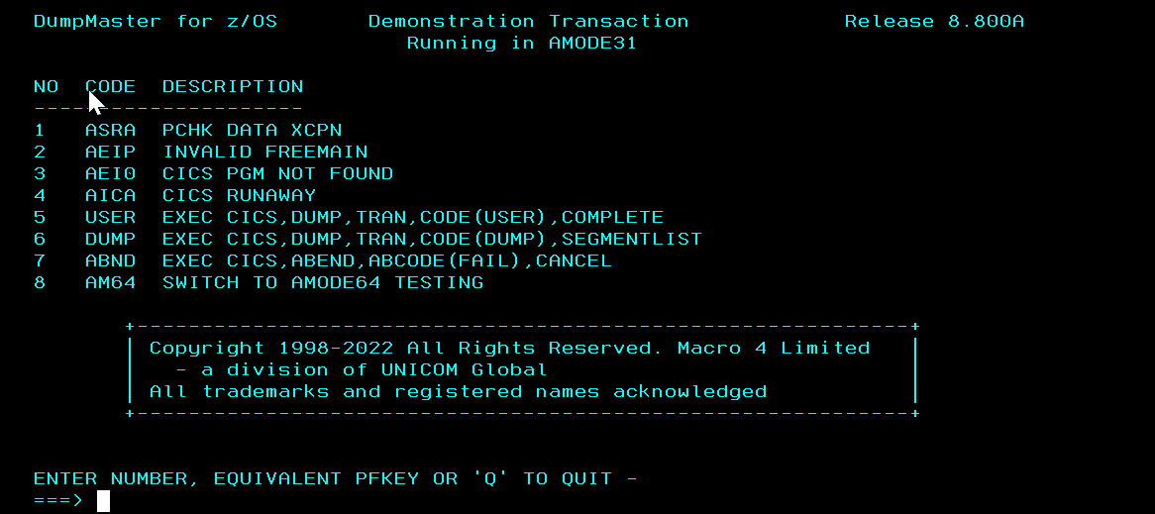

DMST <enter>
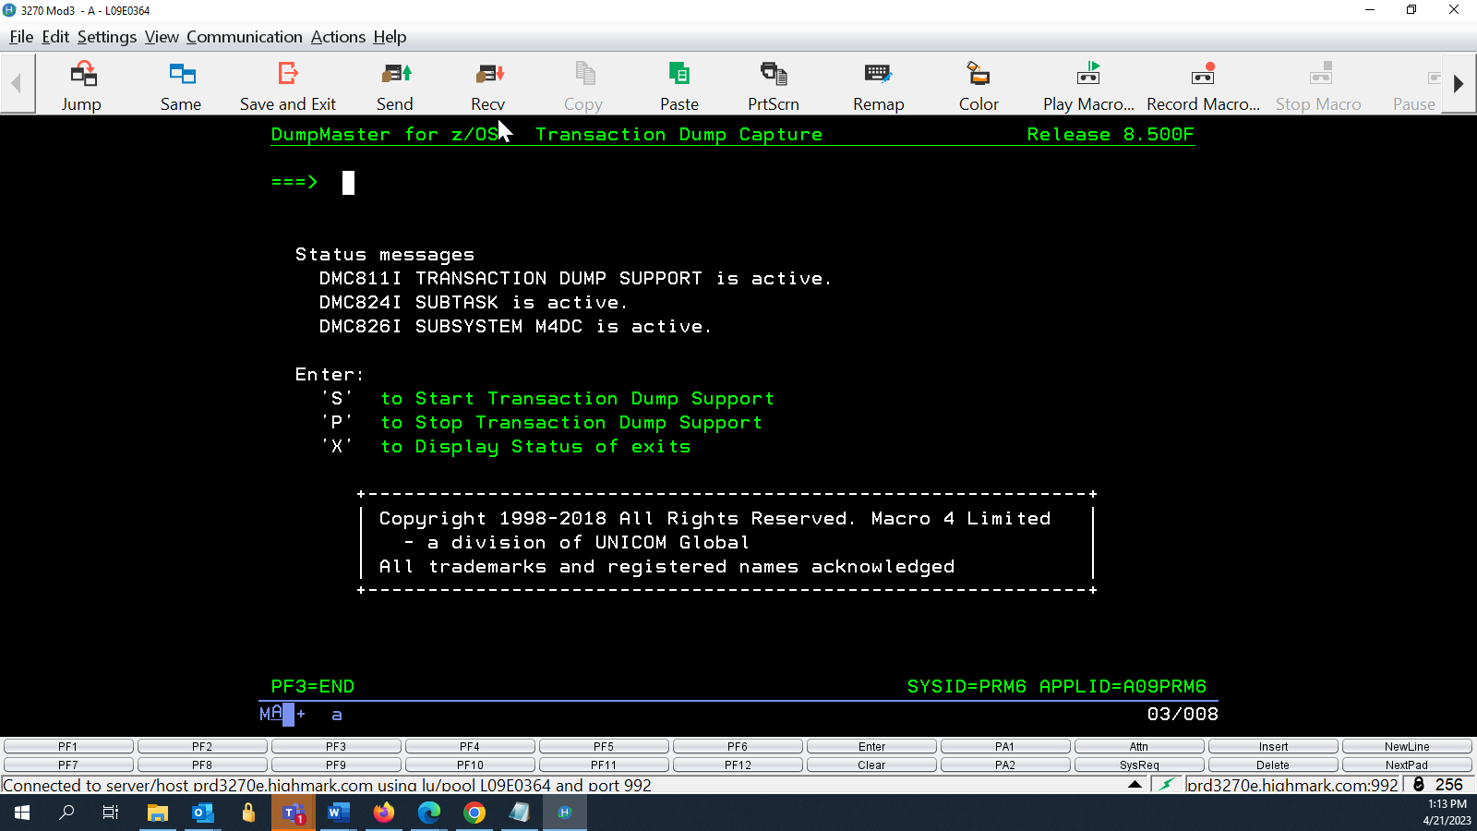
Enter X to see the next screen shot.
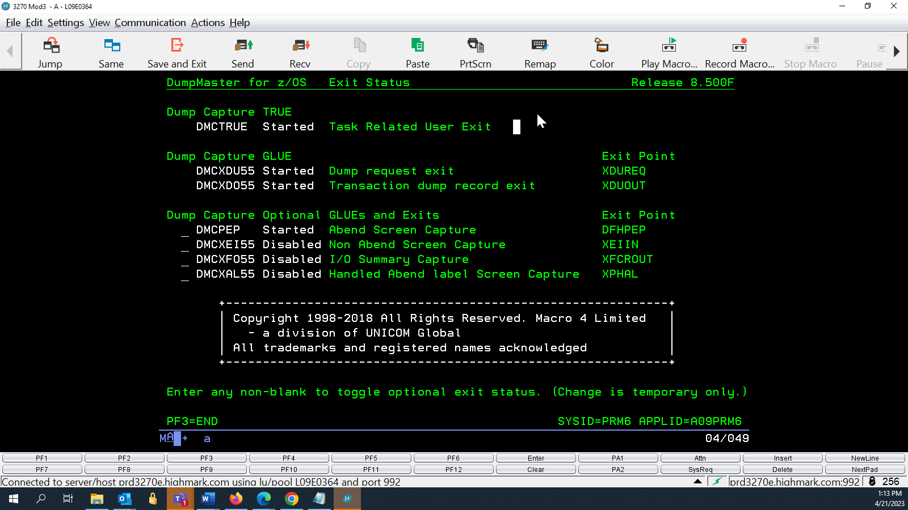

To verify the product, run IVP jobs from SYS3.MACRO4.MDMO880A.SMDMUTIL
ASMA0C7 to link assembler COBC0C7 to link cobol – these only needs run once and will stay linked when copied from SBOX to TEST or PROD
DB2COC7L, RUND0C7L, , RUNA0C7L copy them to SYS3.MACRO4.MDMO880A.INSTALL and customize.

ASMA0C7 needs a VPAMFILE called SYS3.MACRO4.MDMO880A.M4IVP.VPAMFILE
Allocate a new VPAMFILE. Go to M4DM Option 6
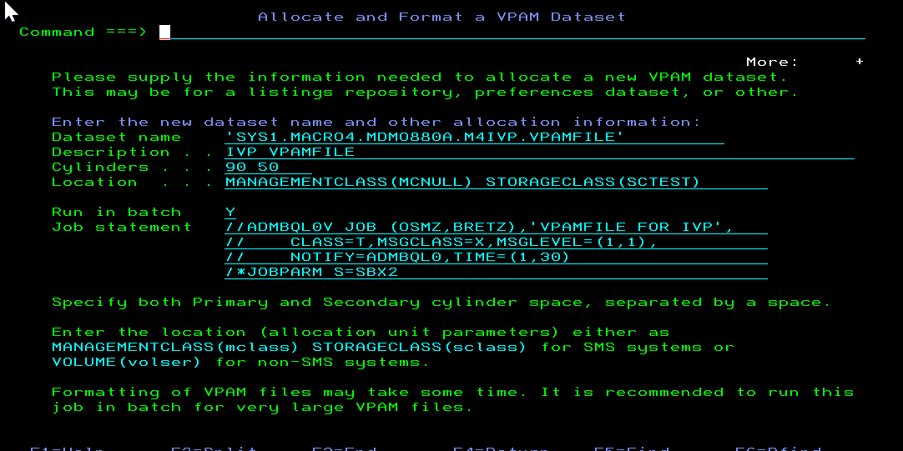
Job SYS3.MACRO4.MDMO880A.INSTALL(CRVPAMFI) can be used instead of using the panels.
ASMA0C7 – This job will assemble an assembler program, add its listing to a
VPAM file, then link the program. Got a RC00
Saved output to SYS3.MACRO4.MDMO880A.INSTALL.OUTPUT(ASMA0C7)
COBC0C7 –

RUNA0C7 – Got a ABEND SOC7 and created a dump

RUNC0C7L - Got a ABEND SOC7 and created a dump

RUND0C7L - Got a ABEND SOC7 and created a dump

On PROD,
Creating a VPAMFILE required a volume for the location:
